# HSearch Developer Guide

# HSearch Processing Levels

1 Merged Row = 1 HBase Row = Many Data Rows

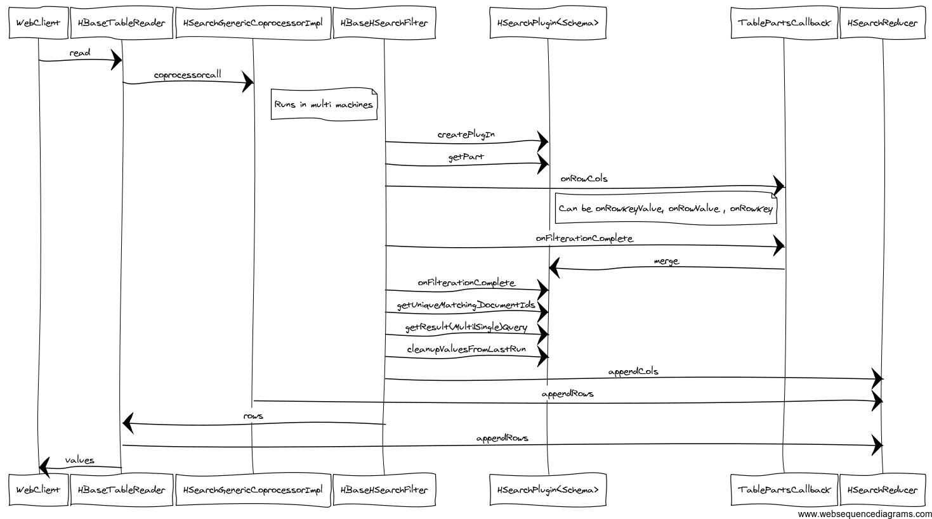

|  |  |  |  |  |
| --- | --- | --- | --- | --- |
| **Processing At** | **Architecture** | **Plugin Point** | **Works On** | **Usage Example** |
| Client | Aggregate data across machines | *HBaseTableReader* | Aggregates on machine output | Find out average score of a state for high school exam |
| Spread to multiple machines hosting multiple region servers | HBase Coprocessor | *HSearchReducerCount*  *appendRows* | Aggregates on Merged Row**s** | Average score across machines output (Many schools) |
| Spread to multiple threads based on the number of queries | HBase filter | *HBaseHSearchFilter HSearchReducerCount:appendCols* (Merge queries output) | Single Merged Row | Merge Id = school  Average score of a school |
| Limited data access as well as parallel disk access | HBase Column Family | *HSearchPlugin<Schema>*  *TablePartsCallback* | A Row |  |